Curriculum- Vitae
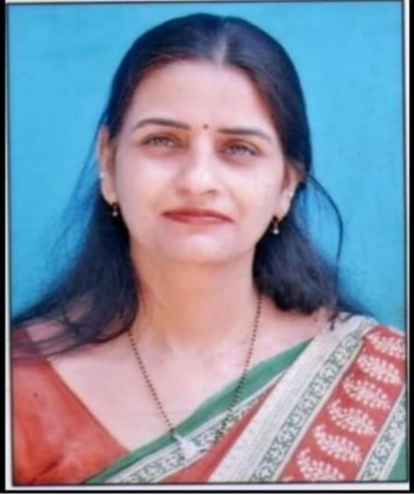
Mrs. Reetu Tyagi
Faculty- Commerce
Methodist Girls (PG) College
Roorkee, Haridwar
Contact no. 9105685868
Email- reetutyagi39828@gmail.com

Educational Qualification
Name of Examination | Year of passing | Board/University | Subject/Group | Percentage of Marks | Division
High School | 1997 | U.P.Board, Allahabad | Science Group | 53.55% | Second
Intermediate | 1999 | U.P.Board, Allahabad | Arts Group | 61.20% | First
B.Com. | 2002 | C.C.S.University, Meerut | Economics Gr., Commerce Gr., Accountancy Gr. | 63.33% | First
M.Com. | 2004 | C.C.S.University | Commerce | 61.33% | First
B.Ed | 2005 | C.C.S.University | Commerce | 60% | First
M.A. (Eco). | 2013 | H.N.B.GarhwalUniversity, Srinagar Garhwal SRT Campus | Economics | 61.11% | First
Ph.D. | Enrolled | Glocal University, Saharanpur U.P. | Finance

Work Experience
From : To | Duration | Name of Organization | Designation
2006 to ongoing | 16 Years | Deptt. of Commerce at Methodist Girls (PG) College, Roorkee (affiliated to H.N.B.Garhwal University, Srinagar) | Lecturer, Assistant Professor
RESEARCH PAPER
- Tyagi,Reetu.Iqbal Mazhar. (2022).Impact Of Financial Crisis On Bottom Line Of Commercial Banks In India: An Empirical Study.Oeconomia Copernicana.volume13 issue 1.727-739
SEMINAR AND WEBINAR
- National Seminar “Vision India, Empowering Youth”on 19th March 2016 in Methodist Girls P.G. College Roorkee.
- International Webinar on “Pandemic Covid-19 and Survival of Indian MEMEs” on 28 June 2020 Glocal University, Saharanpur, U. P.
- International Webinar on “Post Covid Effects and Challenges on the Field of Education” on 7th & 8th July 2020 at Susana Methodist Girls B.Ed College.
- Attended one week FDP on “Research in Social Science” at Glocal University, Saharanpur, U. P. from 6 to 12 november 2020.

Workshop
“Refine your Data Analysis Skills: An Application of SPSS”. COER GROUP OF INSTITUTION. 2021.
ACHIVEMENTS
Translated the book titled “BUSINESS STATISTICS” by Nirupam Publications in hindi.
ISBN: 978-93-84042-56-1

CO-CURRICULAR ACTIVITIES
Participated and got prizes in different co-curricular activities such as skit, essay writing and speech competition.

Personal Information

Date of Birth :December 08, 1981
Permanent & Present Address: 282, Lane no. 7, ram nagar roorkee
PIN- 247667

Marital Status : Married

DECLARATION
I hereby declare that all the information given above is true to the best of my knowledge and belief.
Yours Sincerely

Mrs. Reetu Tyagi

